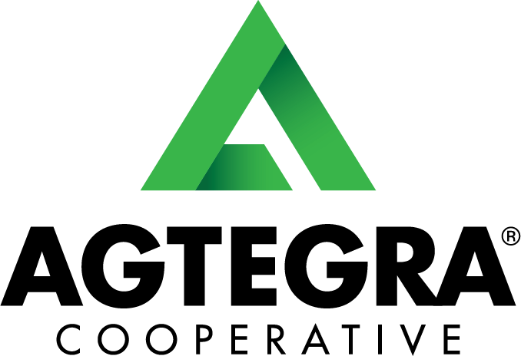
Strategic Implementation of a Digital Billboard at
Agtegra’s Andover Grain Terminal

Agtegra Admin Intern Group Project
Lane Kruger & Nick Hogan
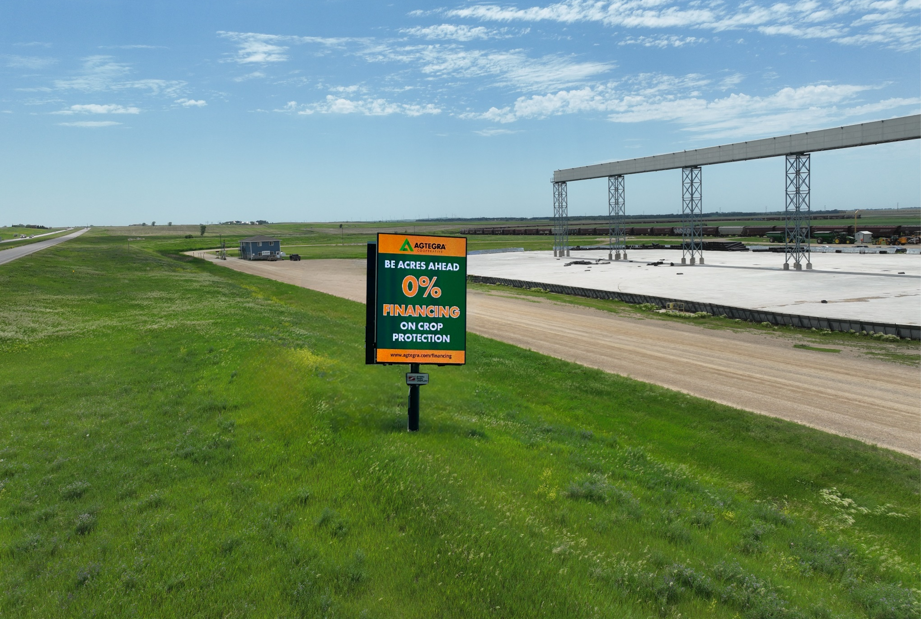
08/05/2025
Executive Summary:

This report presents a case study examining the feasibility, logistics, and financial outlook for installing a dual-sided digital billboard along Highway 12 at the Andover Grain Terminal. This location was selected by project managers prior to being assigned the project. The goal of this project is to increase Agtegra’s long-term communication and outreach goals and provide the cooperative with another source of revenue.
The project proposes using a 14’x19’ V-shaped digital sign, equipped with modern features such as an automated brightness adjustment, animation capabilities, and remote upload access. Beyond marketing purposes, the billboard would serve Agtegra’s internal departments by promoting Agtegra’s communication and branding goals.
The estimated total lifetime cost for the billboard is $418,275, with potential annual revenues ranging between $64,800 - $108,000 depending on advertiser participation. With a breakeven point between 3.87 - 6.45 years, the investment offers a promising return and significant brand visibility for both Agtegra and its partners.

Project Background & Rationale:
As Agtegra continues to expand its marketing capabilities and opportunities, the implementation of the owned assets for strategic use is always growing. Digital billboards offer a flexible and modern way to communicate directly with thousands of daily drivers, including locals, growers, partners, and out-of-town visitors heading to either the Andover Grain Terminal or just traveling along Highway 12. Since the highway is a direct access point to I-29 it captures many motorists from Northeast SD.
The Andover Grain Terminal being selected as the location of the digital billboard at 13701 U.S. Highway 12, SD, averages 1,984 daily views based on Department of Transportation reports from 2015 - 2023. This location is compliant with state DOT and SDCL 31-29-63 regulations, given its 100-foot setback from the highway and its classification under the C5 Census Code, which permits digital signage within incorporated towns. This ensures both safety compliance and excellent visibility. The sign is also equipped to manage a variety of changes from day and night sensors to limit light exposure.

Technology Specifications:
The proposed sign will be a V-shaped, dual-sided 14’ x 19’ structure, equipped with a variety of features with:
- 275x360 resolution per side.
- Brightness sensors: to automatically dim in low-light conditions. This will allow us to abide by day and night light regulations to not distract drivers.
- Motion/animation support: for slide, fade, or simple transitions. This will allow for the possibility of more creative graphics and advertisements.
- Remote content uploads: The cloud service known as the Venus Control Suite can be used for instant and easy upload of advertisements or changes of the board for rapid ad changes or updates. An agreement with advertisers would allow them the ability to change out any mistakes or new advertisements within a 72-hour window.

These features are selected to balance attention-grabbing effectiveness with driver safety.

Risk Mitigation & Safety Considerations:
As with any roadside digital signage, safety and environmental impact were carefully reviewed. Safety plays a significant role both within and in the communities that they serve. The key risks and their mitigations are as follows:
Concern | Description | Mitigation
Driver Distraction | Rapidly changing content could divert attention from the road | Limit ad changes to once every 10 seconds per DOT recommendations
Glare / Light Pollution | Bright lights could impair driver vision, especially at night | Auto-dimming sensors and capped brightness settings ensure safety
Visibility Obstruction | Poor placement could interfere with sightlines at intersections or turns | Sign set back 100ft and aligned per SDCL 31-29-63 and DOT visibility rules
Weather Damage | Exposure to hail, snow, wind could damage the structure or electronics | Weather-resistant materials, reinforced frame, and routine maintenance checks

Insurance:
While damages to the board are unlikely, it is still a smart business practice to purchase insurance on the signage. The sign will have to be covered under a separate insurance policy, allowing for a lower deductible when compared to including it into an already existing policy for the facility. The board is:
- Weather-tested
- Resistant to sun bleaching
- Rated to withstand high winds and normal storm conditions

The only serious weather concerns are large hail or tornados, both of which are accounted for in insurance risk models and repair cost projections.
Cost Breakdown:
The total estimated cost is over the expected 10-year life. The sign is estimated to last a minimum of 10 years and is based on Daktronics and Steins previous installments. The cost of the billboard includes the following:
- Installation & Equipment (with 4% sales tax): $271,776
- Lifetime Operations & Power Costs: $48,679
- Extended 5-Year Parts Warranty: $25,000
- Insurance Policy (lifetime): $20,000
- Marketing Screening Tool (lifetime): $2,400
- Expected Repair Labor: $50,000
- Permit & Road Signage Fees: $420
Total Lifetime Investment: $418,275
These figures were compiled based on quotes, regional averages, and vendor input coming to a total lifetime investment cost.
Partner Strategy:
A targeted outreach plan would be the best approach to finding partners who will benefit from our sign. During our project, we reached out to four Agtegra partnered companies that would be extremely interested if this sign became a reality. We scheduled and met with NK, Koch, Brevant and Syngenta, where we gained valuable insight into all aspects of our proposal for advertisements. The number of sponsors will be limited and made up of pre-approved Agtegra partners. This will ensure that Agtegra has control of the messaging and that the brands are aligned with Agtegra’s goals. The exclusivity of industries is enforced on a first-come first-served basis. To avoid conflicts, encouraging early commitments, or long-term contracts.

Revenue Model:
Sponsorship Levels & Pricing (Per Side)
Each side of the billboard can host up to 15 sponsors, with ad play percentages allocated by tier.
Tier | Time Allocation | Plays/  Day | Monthly Rate | Maximum Sponsors | Avg. Ad Time/Day
Bronze | 10% | ~864 | $500 | 8 | 0.3 hrs.
Silver | 15% | ~1,296 | $750 | 4 | 0.9 hrs.
Gold | 25% | ~2,160 | $1,000 | 2 | 3 hrs.

Add-on Options:
- Simple Animations (fade, slide): +$100
- Priority Start Date: +$100 one-time
- Ad Change: Free
- Contract Discounts: 10–20% depending on term length

Discounts for Long Term Contracts:
- 3 Months: -10%
- 6 Months: -15%
- 12 Months: -20%

ROI Projections & Scenarios:
These figures do not include any additional internal value derived from Agtegra-specific messaging or saved marketing costs.
Scenario 1 – Full Capacity (100% Sponsor Use):
- Monthly Revenue = $9,000
- Annual Revenue = $108,000
- Breakeven = $418,275 / $108,000 = ~3.87 years
- Potential Profits= $108,000 x 6.13 years = $662,040
Scenario 2 – Partial Capacity (60% Sponsor Use):
- Monthly Revenue = $5,400
- Annual Revenue = $64,800
- Breakeven = $418,275 / $64,800 = ~6.45 years
- Potential Profits = $64,800 x 3.55 years = $230,040
Internal Value to Agtegra:
This billboard will not only generate revenue for Agtegra, but it will also be a major source for internal communications:
Tier | Time Allocation | Plays/  Day | Monthly Rate | Maximum Sponsors | Avg. Ad Time/Day
Agtegra (Internal Use) | 50% | ~4,320 | Internal Rate | 1 | 12 hrs.

- Job Postings: Recruiting for any department, this could target both those looking for roles within any department or those looking for labor jobs or trucking.
- Local Events: Promoting cooperative events or incentives for joining the co-op.
- Agtegra Products + Services: Highlighting seasonal promotions and new services for increased brand recognition and advertising.
- Departmental Announcements: Driving engagement with each of Agtegra’s business divisions.

These uses make the investment beneficial even during periods of lower external sponsorship and may qualify the project for co-op marketing dollars.

Next Steps:
Some next steps could include reviewing the return on investment and analyzing the strategy and concept of internal billing via direct bill or an internal credit system. Another step would be to check with even more partners companies to further gauge interest across our business divisions.

Installation Timeline:
A full installation is projected to take approximately 10 - 12 weeks, assuming the timely ability to contract a contractor and part delivery. This is according to the suppliers of the electronic parts at Daktronics and the sign installers at Stein Signs. Not every installation task requires the previous task to be completed, such as the parts being delivered and the dredging of the power for the sign at the site, which allows for parallel tasks. The general tasks that are required to complete the installation include:
- Parts Delivery: 3–4 weeks
- Foundation/Base Installation: 2 weeks
- Digital Sign Assembly and Mounting: 6 weeks
- Wiring and Electrical Setup: 1 week
- Power Hookup by 3rd-Party Electrician: 3–5 weeks
Coordination with local utility providers and permitting bodies will be key to staying on schedule. Other than Daktronics and Stein Signs, a third-party electrician or utility company will need to be contracted out for the power supply’s final hookup as neither supplier can do the official power hookup.

Conclusion:
This case study outlines a great opportunity for Agtegra to invest in a long-term reliable advertising and communication tool. The Andover Grain Terminal offers minimal safety risks, high visibility, and significant brand visibility but also has high potential for financial return. This billboard will not only support Agtegra and its partners relationships but will also enhance the company’s internal messaging capabilities. With our advertising tiers and careful management, Agtegra will benefit with better brand awareness and community outreach.

